TRIBHUWAN UNIVERSITY
Institute of Engineering
HIMALAYA COLLEGE OF ENGINEERING
Kalopul, Kathmandu
Nepal.

A Project Report

On

Computer programming-I

“The Library”

Submitted By:- Submitted to:-
Group Name: sajeb Department of Computer Engineering
Group Members: HCOE
Bhupal Sapkota (11/062),
Janak R. Pathak(15/062),
Samir Thapa(27/062)
Group: BCT/062
Level: I/I
Date: March 19th, 2006
Foreword to the project

C has been developed as programming language. C is a general purpose structured programming language that is powerful, efficient and compact. C combines the features of a high level language with the elements of the assembler and is thus close to both man and machine.

In this project, we are implementing the C course we have done as prescribed by the syllabus of TU, IOE, Computer programming-I for the first year first part of Bachelor’s Degree in Computer Engineering.

This project work is joint venture for making a library database. The member of this sajeb group are Bhupal Sapkota (11/062), Janak Raj Pathak (15/062) and Samir Thapa (27/062). This project work is termed as “The library”. This C program is fully oriented in record keeping, manipulating and editing database for library purpose. We have fully tried our best to make it user friendly in the view of all its operation.

We are thankful to our teacher Mr. Uma Shankar Pandey for his valuable suggestions and immense support in completing this project. We are too grateful to all the friends and everyone who helped us in making this project successful.

Genuinely Yours,
Sajeb group,
BCT / 062

“The Library”
Introduction:
This C program is combination of library functions, user defined functions, files and many other operation in C. Our intension of program is to make a program that stores library records as entered by user, adds records, searches record, deletes record and many other applications regarding database.

Program Directives

Global Declarations
- Start
- void intro(void); //Startup page;
- int guest_welcome(void); Guest Welcome Screen
- int admin_welcome(void); Administrator Welcome Screen
- void welcome(void);//Determines Whom to welcome?? Admin or Guest
- void misuse(void);// ENDs program bcoz of Unauthorized access if tried
- void bye(void);// The Last THANK YOU SCREEN
guest_login() is by default called
if secret key pressed
admin login (password protected)
else guest login(default)
if UNAUTHORIZED access is tried for more than 3 times, misuse()
function is called, finally calling bye() function program ends
- void home(void); //MAIN MENU OF THE PROGRAMME
- void setscreen(void); //Sets the Screen and Key Frames
- void html(int htm);// if htm=0 ALL DATABASE if htm=1 SINGLE BOOK
This function is used to export our database into HTML file format.
- void printer(int prn); //To print the whole database
Our database will be printed by this function.
if setscreen() is choosed , main display screen starts here
- void box(int x1,int y1,int x2,int y2, char *text); //makes box
- void status(char *); //To display changing status of screen
- void which_view(void); // Which view is being used??
- void tabview_set(void); //Sets tab view area
- void view_set(void);//Set one at a time area
- void oneatimeview_set(void); // Sets One at a time FIELDS
- int read_data(void); //Reads data from datasource
- void oneatime_show(void); //Display Records one at a time in the FIELDS
- void tabview_show(void); //Display in Tabular form form
- void bulet(int a,int b); // Bullet for tab view selection
/*Special Functions*/
- void addbook(void);//Adding book through keyboard
- void mainloop(void); //The main loop that controls display screen
- int writebook(void); //To write books to file,1 at a time
- int editbook(void);// Edit book info stored
- int input(int x,int y, char *,int length);
- int searchbook(void);
- int writehtm(char *);//Creates a HTM FILE Under C:\
- int password(int x,int y, char *pass,int length);
- void cls(void); // For both views clears USER DATA DISPLAY AREA
- void clsview(void); //Clears the fields to print next record for 1 on 1 view
- void clstab(void); //Clears the 26 items of TABVIEW
/*Integer Values used for Control*/
char ch='n'; //Ch to hold user input- a character at a time
int x=6,y=8,i,j; // TO set screen col, row & Loop variables
int len;//For length of strings
icnt unauth=0; //Counts Unauthorized Access number
long int recno=0; //no of records record used as INDEX for book array
long int maxrec=0;
int count=0;
//flags
/*Integer Values used for Control*/
unsigned char ch='n', ch2='n'; //Ch to hold user input- a character at a time
int x=6,y=8,i,j; // TO set screen col, row & Loop variables
int len;//For length of strings
int unauth=0; //Counts Unauthorized Access number
long int recno=0; //no of records record used as INDEX for book array
long int recold=0; //Temp store for Switching betn diff modes
long int maxrec=0,rec_size;
int count=0; //For counting purpose

struct library
{
char name[30],author[30],pub[30],edition[5],isbn[30];
char lc[5];
char accno[15],bookno[15];
char issue_to[20],issue_date[11],due_date[11];
};
struct library book;
struct library tmp;// To use to edit Book info
FILE *fp,*ft;

char *pass;
char pword[]="buparo"; //Sets password for Administrator
char *field="NAME(S) OF THE BOOK";
char *title="THE LIBRARY, HIMALAYA COLLEGE OF ENGINEERING, KALOPUL";
char *bullet="->";
char *msg;
char *tempo; //Temporary character storage

Welcome window:
The introduction window of the program is defined by the intro() function.
void intro(void) // INITIAL STARTUP SCREEN
The screen looks as following to the user:
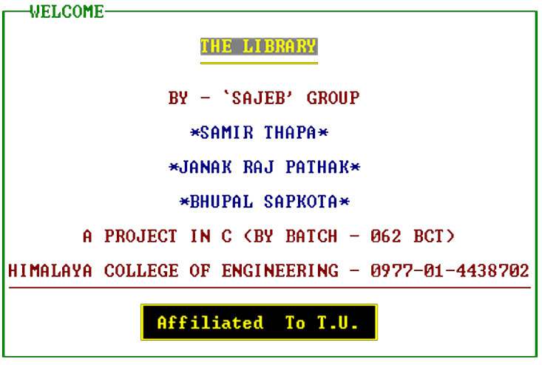

A user can continue if he presses either <space> or <esc>

Guest Login window
The program begins from here. The password is asked if a secret key is pressed. If the password is correct the user is logged on as administrator otherwise a guest. A guest user can just view the database. If three unsuccessful attempts are made to enter password, the program is terminated.
The logon screen and the misuse functions are defined below.

int guest_welcome(void)
{
clrscr();
textcolor(GREEN);
box(15,10,65,30,"THE LIBRARY : GUEST LOGIN");
textcolor(RED);
gotoxy(35,20);cprintf("WELCOME!");
gotoxy(35,21);cprintf("ÄÄÄÄÄÄÄÄ");
textcolor(GREEN);
gotoxy(40,22);cprintf("GUEST");
for(;;)
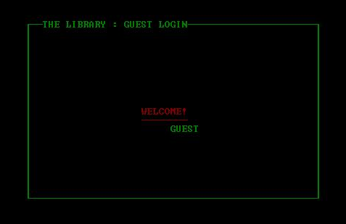
{ch=tolower(getch());
if (ch==32||ch==13) return 0;
else if (ch=='a') return 1;
}
}

We get this output this code: If user presses the secret key defined in this function he will be switched to Administrator login screen where the admin password is asked.

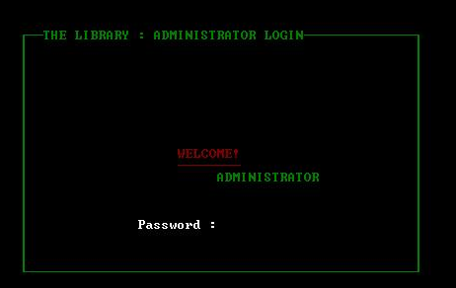
Administrator Login window
User is supposed to be admin as he knows secret key and comes to administrator login screen.

If correct password is entered user will be allowed to enter database HOME MENU as Administrator otherwise will be switched back to Guest Login Screen.

The HOME Window
This is the main loop of the program, from where user can either enter to database viewing screen or export the whole database in HTML format or print the whole database.

void home(void)
{
clrscr();
if (view==1) //Administrator
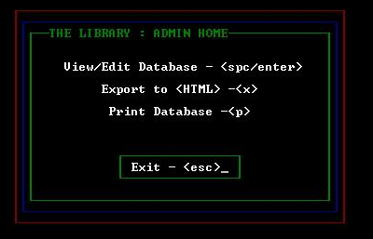
box(20,15,60,30,"THE LIBRARY : ADMIN HOME");
else//Guest
box(20,15,60,30,"THE LIBRARY : GUEST HOME");
textcolor(WHITE);
gotoxy(25,18);
cprintf("View/Edit Database - <spc/enter>");
gotoxy(30,20);
cprintf("Export to <HTML> -<x>");
gotoxy(30,22);
cprintf(" Print Database -<p>");

textcolor(GREEN);
box(32,26,48,28,"");
textcolor(WHITE);
gotoxy(34,27);
cprintf("Exit - <esc>");
}

Database Viewing Window
This is the database viewing screen. A frame that contains information about book records, available hot- keys and other frames are on the screen. A user can know about what he can do with the database. This outlook is achieved as the output of function:
void setscreen(void); //Sets the Screen and Key Frames
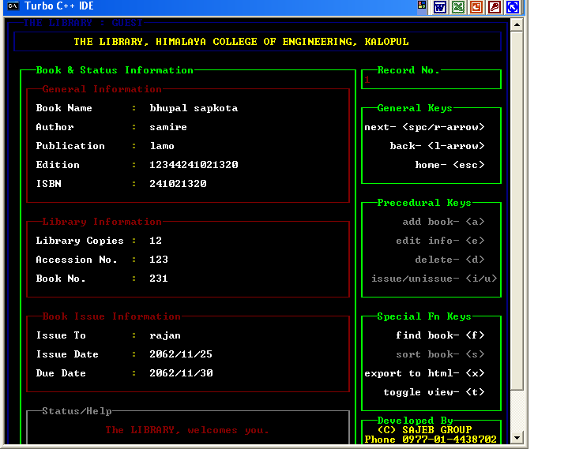
The user can switch between tabular view and above shown one a time view. This one a time view provides information about the book records stored, one at a time where as in tabular view 26 book names will be shown at a time, user can select any one of the book and press enter- program wiil show user the corresponding book information.

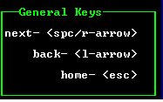
There are 3 categories of hot-keys available to user.

The general keys – space or left arrow to see next records, right arrow key to see previous record. Pressing esc key returns user to HOME windows.

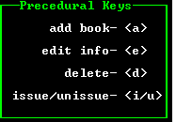
The procedural keys- perform specific tasks related with stored book records. These functions are active to Administrator only. Admin can add, edit, delete and issue/un- issue a book. This frame will be inactive to Guest.
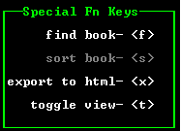
The Special function keys: perform find, sort, export to HTML, toggle view in the database.

Thank You – Window
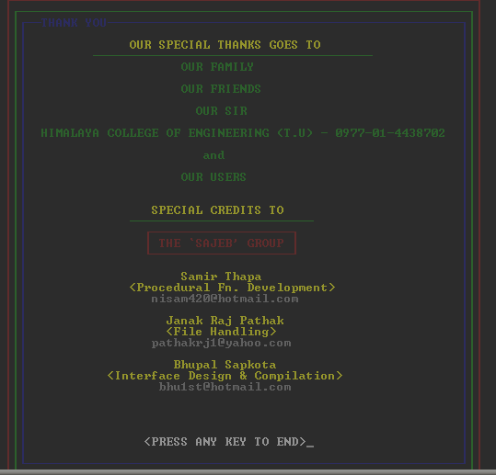

It gives programmers short description and ends the program by thanking user.

Complimentary Notes from SAJEB
We learned a lot about concept of computer programming – C- language. The toughest work during programming was to build a nice looking user interface which was properly tackled by Bhupal Sapkota. Without using any C- graphic function, we made a really nice looking user interface. The extended ASCII codes were the best helpers here.

The file handling part was also a tickling one. Though our group member Janak Raj Pathak handled it properly.

Anything won’t have been such working if no proper functions were designed and implemented by Samir.

The main feature of the library program is its low memory dependency, low file size and high performance quality. It would be a nice choice for such users who don’t own hi-equipped computers, or least no library on their own, but want to use a program that keeps track of their available home books information in computer database. In near future, The project will be a complete library management software.

At last, though our first program, we enjoyed a lot during this project time. It was a great time with C.

Thank you very much.

